### Mississippi School Plant Managers Association

2025 Annual Conference

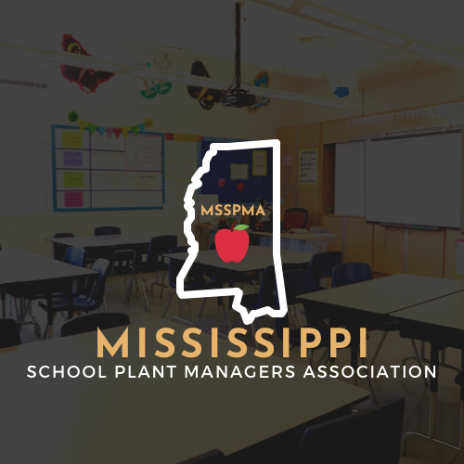

Tuesday, October 28- Conference

Clyde Muse Center - Hinds Community College - Rankin Campus

MSSPMA

884 Luckney Road Brandon, MS 39047

601-992-6006 - phone 601-992-4008 - fax

[groganmnga@aol.com](mailto:groganmnga@aol.com)

www.msspma.com

### MSSPMA

### Annual Conference Booth Reservation Form

Oct 28, 2025

Clyde Muse Center - Hinds Community College - Rankin Campus

515 Country Place Parkway

Pearl, MS 39208

Name of Vendor:____________________________________

Representative:________________________________________

Telephone:________________________ Fax:________________

Email Address:_________________________________________

Address:______________________________________________

City:_______________________ State:__________ Zip:______

One representative from each booth is invited to join us for continental breakfast and lunch. Additional representatives may join the breakfast and lunch for an additional cost of $20.00 per representative. Please list additional representative’s names so a name tag and registration packet can be provided. We will furnish one table and 1 chair per booth. Vendors will furnish all furniture, table covers and supplies except the table and chair.

One Booth Space $500.00 ______________

Two Booth Space(s) $600.00 ______________

Three Booth Space(s) $900.00 ______________

Electricity Fee $ 50.00 ______________

Additional Breakfast & Luncheon Ticket_____ x $20.00 ______________

Total Amount Due ______________

Please indicate if you will need electricity in your booth: _______________

Please list additional Representatives names here for name tags and planning purposes:

____________________________________________________________________________________________________________________________________

Please note MSSPMA does not accept credit cards

The deadline for returning this completed form to the MSSPMA office is Friday, Sept 5, 2025. Please call regarding availability of space if unable to meet these deadlines.

MSSPMA

884 Luckney Road Brandon, MS 39047

601-992-6006 - phone 601-992-4008 - fax

[groganmnga@aol.com](mailto:groganmnga@aol.com)

**Mississippi School Plant Managers Association**

###### Cherrell Grogan

**884 Luckney Road**

**Brandon, MS 39047**

**Phone: 601-992-6006**

**Fax: 601-992-4008**

[**Groganmnga@aol.com**](mailto:Groganmnga@aol.com)

**Thank you for your interest in the Mississippi School Plant Managers Annual Conference. Booths will be set up Monday, Oct 27,2025 beginning at 2:00 p.m. in the Clyde Muse Center - Hinds Community College - Rankin Campus. These booths will be pre-assigned. Upon your arrival you will be directed to your booth. MSSPMA no longer will provide first come first serve set-up. Booths must be removed by 6:00 p.m. Tuesday, Oct 28, 2025.**

One Representative from your booth is invited to be our guest at the continental breakfast Tuesday morning and the noon luncheon. Additional representatives are welcomed at a cost of $20.00 per person. To show our appreciation for your participation a prize drawing will be held during the luncheon. Prizes will include a free booth for the 2026 Conference.

###### Door Prize Info

**Please note door prizes will be given out throughout the conference. If you have novelty gifts that you would like to give away, those should be given away at your booth and not be considered door prizes. If you wish to have a door prize drawing from names you accumulate at your booth, you may bring those to the registration desk along with your fishbowl/basket and we will draw and announce for you on Tuesday afternoon.**

**MISSISSIPPI SCHOOL PLANT MANAGERS ASSOCIATION**

**2025 CONFERENCE**

Clyde Muse Center - Hinds Community College - Rankin Campus

515 Country Place Parkway

Pearl, MS 39208

Tuesday, Oct 28, 2025

**Conference Sponsor**

Conference Sponsorships are vital to the success of MSSPMA's conference.

* Lunch Sponsor ($5,000) Free Booth Included
* Conference Sponsor ($2,500) Free Booth Included
* Platinum Sponsor ($1,500) Free Booth Included
* Gold Sponsor ($1,000) Sponsorship Plaque Included
* Silver Sponsor ($500)
* Bronze Sponsor ($250)
* Patron Sponsor ($100)

Contact Name:__________________________________________________________________

Company Name:________________________________________________________________

Address:_______________________________________________________________________

Phone/Fax:_____________________________________________________________________

E-Mail:________________________________________________________________________

Please make checks payable to MS School Plant Managers Association

884 Luckney Road Brandon, MS 39047

Fax - 601-992-4008

groganmnga@aol.com